**This week at OBC (June 18-25, 2017)**

**Sun. 18**-Adult Sunday School, 9:30am (Library)

* Morning Worship 10:45am

Happy Fathers Day!

**Mon. 19**- Cara in office 9-12

* Food Pantry Distribution 4-6

**Tue. 20**- Food Pantry Distribution 12-2

Social Hall in use, 5pm for IHOC Board meeting

**Wed. 21**- Cara in the office 9-5

**Thur. 22**- AA in Social Hall, 8pm mtg.

**Fri. 23-**Church office closed

**Sat. 24-** Church Picnic at Soupy Island

**Sun. 25-** Adult Sunday School, 9:30am (Library)

* Morning Worship 10:45am
* Youth Group 6-7:30pm

\

Oaklyn Baptist Church

29 E. Bettlewood Ave.

Oaklyn, NJ 08107

~~~~~~~~~~~~~~~~~~~~~~~~~~

Office: [Oaklynbaptist@gmail.com](mailto:Oaklynbaptist@gmail.com)

Pastor Kelly: [OBCPastorKelly@gmail.com](mailto:OBCPastorKelly@gmail.com)

Office Phone: 856.854.8555

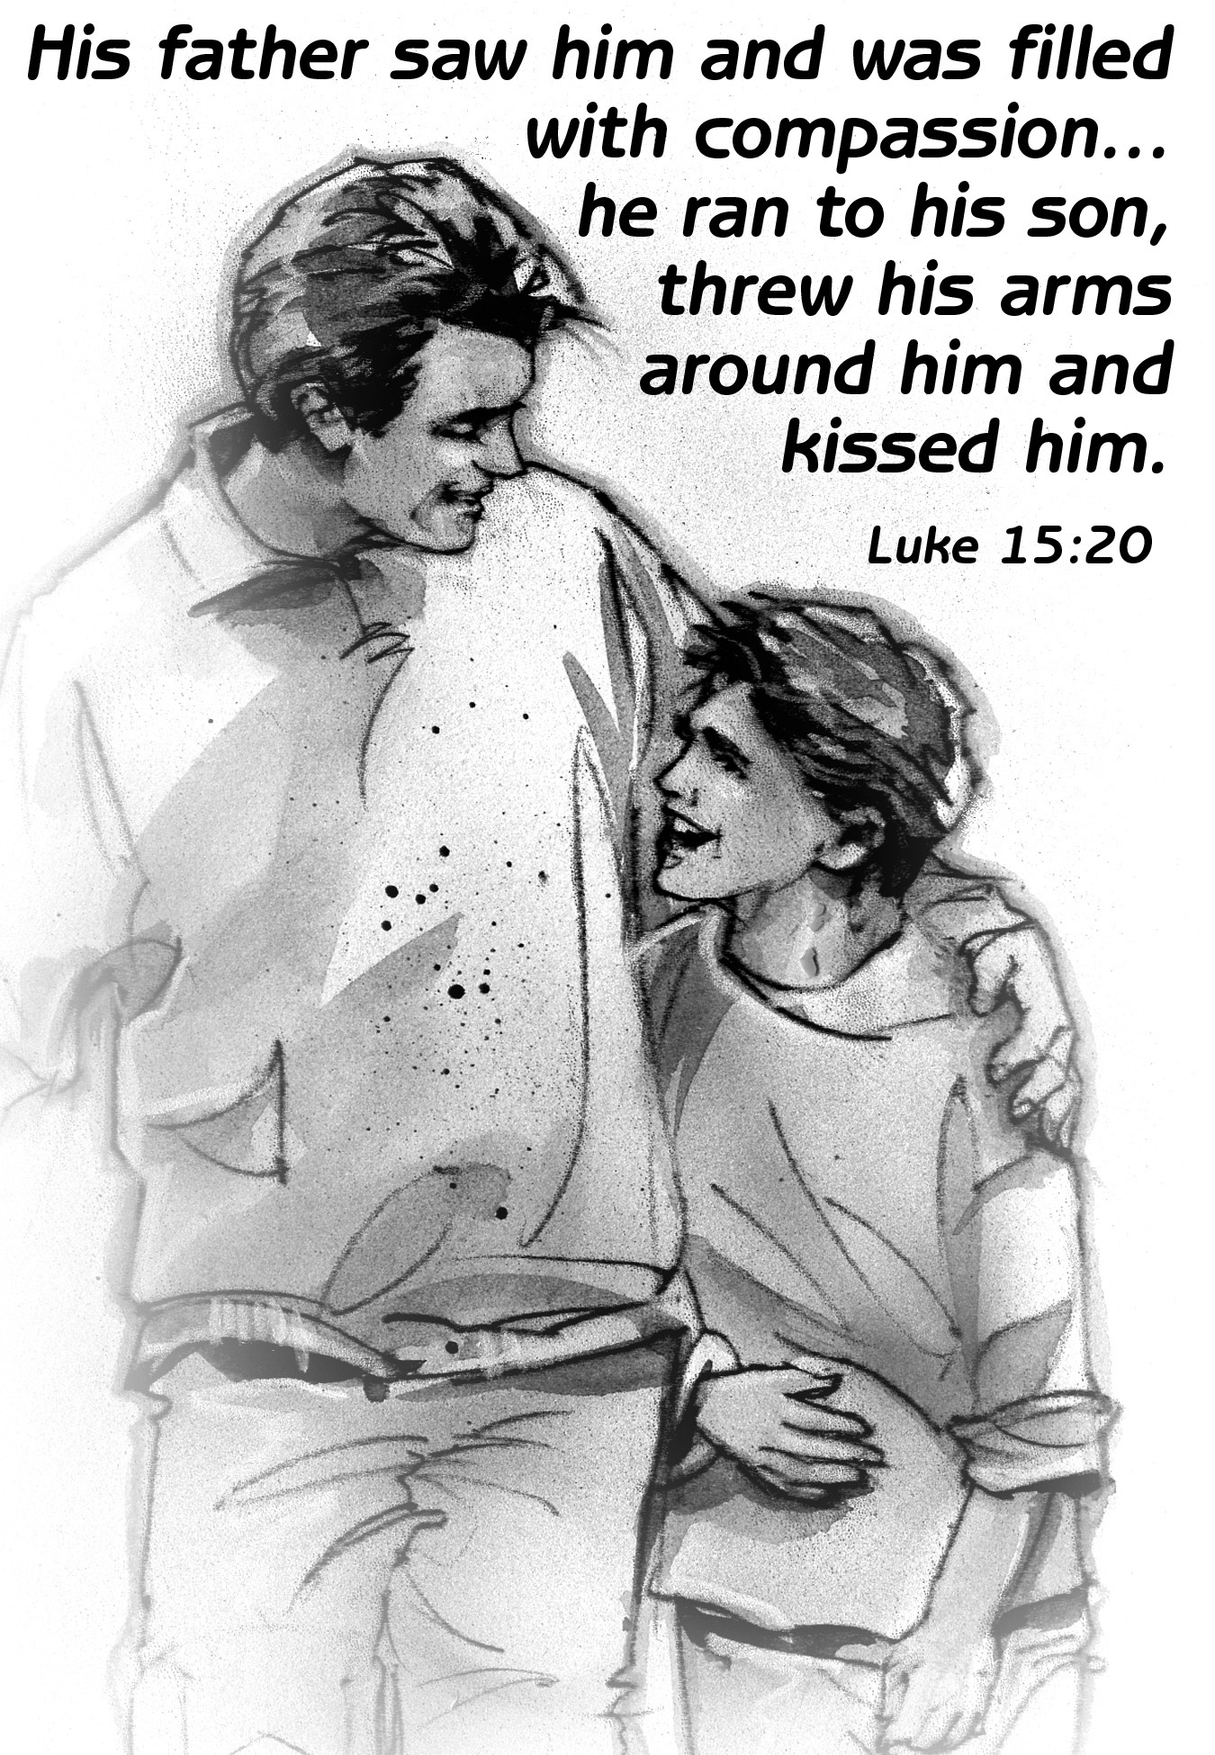

**\*Glory Be** (Sung)

*Glory be to the Father, and to the Son, and to the Holy Ghost; As it was in the beginning is now and ever shall be, world without end. Amen, Amen.*

**Scripture Readings:** Genesis 18:1-15 & Romans 5:1-8

*[We encourage you to follow along in your bible, a pew bible or on your electronic bible]*

**Congregational Singing:** “Jesus Calls Us” #345

**Offertory Prayer**

**Offering Received** *[If you are a visitor today please know that, while we welcome your participation in our offering, you are our guest, and as such, should not feel obligated to give].*

**\*Doxology (sung)** *Praise God from whom all blessings flow; Praise Him all creatures here below; Praise Him above, ye heavenly host. Praise Father, Son and Holy Ghost.*

**Prayers of Concern & Celebration**

**Children’s Message**

(Children dismissed ages 6-6th grade for Kids Club)

**\*Congregational Singing:** “Grace Like Rain”

**Scripture:** Matthew 10:9-23

**Message:** “Mismatched”

**\*Congregational Singing:** “Wonderful Grace of Jesus” #345 &

“Amazing Grace (My Chains Are Gone)”

**\*Benediction**

*(*Please stand if you are able)*

Welcome to

Oaklyn Baptist Church

Morning Worship

June 18, 2017 ~10:45am

Pastor: Rev. Kelly Grimsley

[www.oaklynbaptist.org](http://www.oaklynbaptist.org) 856.854.8555

|  |
| --- |
| **Order of Service** |

**Announcements**

**Prelude**

**Call to Worship:**

Leader: We come to you this day with burdens and cares in our hearts.

***People: Lord, take these burdens from us and ease our souls.***

Leader: We come to you this day with fear and uncertainty about the future.

***People: Lord, calm our fears and help us to place our trust in you.***

Leader: Come; let us worship God, whose love is abundant.

***People: Let us praise the God of our salvation who watches over us always.***

***All: We come to pray. We come to sing. We come to worship and praise.***

**\*Congregational Singing:** “Lord I need You”

**\*Unison Invocation and Lord’s Prayer:**

Open our hearts today, O Lord, to feel the powerful strength and love you have for us. Help us to listen, not only with our ears, but with our spirits for your words of compassion and healing. Enable us to become more faithful disciples for you. Come, Lord God, and be with us in this hour. Speak a word of comfort to your troubled people. Help us hear you in the quietness

of these moments. We ask in the name of Jesus, who taught us to pray…

**\*The Lord’s Prayer**

*“Our Father, who art in Heaven, hallowed be Thy name, Thy kingdom come, Thy will be done on earth as it is in Heaven. Give us this day our daily bread and forgive us our trespasses: as we forgive those who trespass against us. And lead us not into temptation, but deliver us from evil. For Thine is the kingdom, and the power, and the glory forever. Amen”*